Transit Future Campaign Supporters

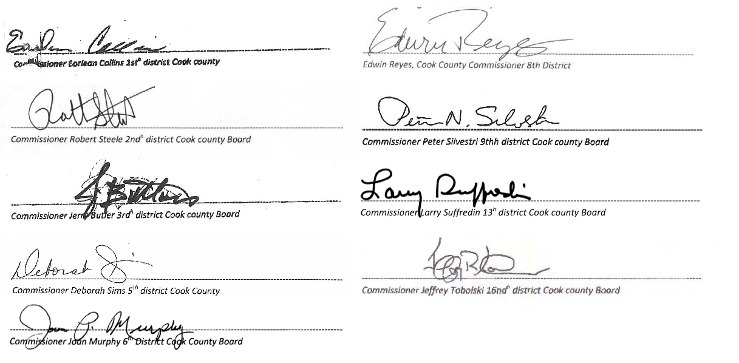
Commissioner Jeffrey Tobolski, 16th District Cook County Board

Commissioner Larry Suffredin, 13th District Cook County Board

Commissioner Peter Silvestri, 9th District Cook County Board

Commissioner Edwin Reyes, 8th District Cook County Board

Commissioner Joan Murphy, 6th District Cook County Board

Commissioner Deborah Sims, 5th District Cook County Board

Commissioner Jerry Butler, 3rd District Cook County Board

Commissioner Robert Steele, 2nd District Cook County Board

Commissioner Earlean Collins, 1st District Cook County Board

Cook County Commissioners

Leadership Group

Frank Beal
Carole Browne
Christopher Burke
Ron Burke
Warren Chapman
Ellen Craig
David Mosena
John Schmidt
Tom Villanova
Karen Walker
Doug Whitley
Bob Weissbourd

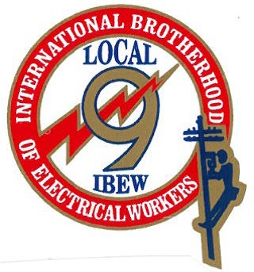
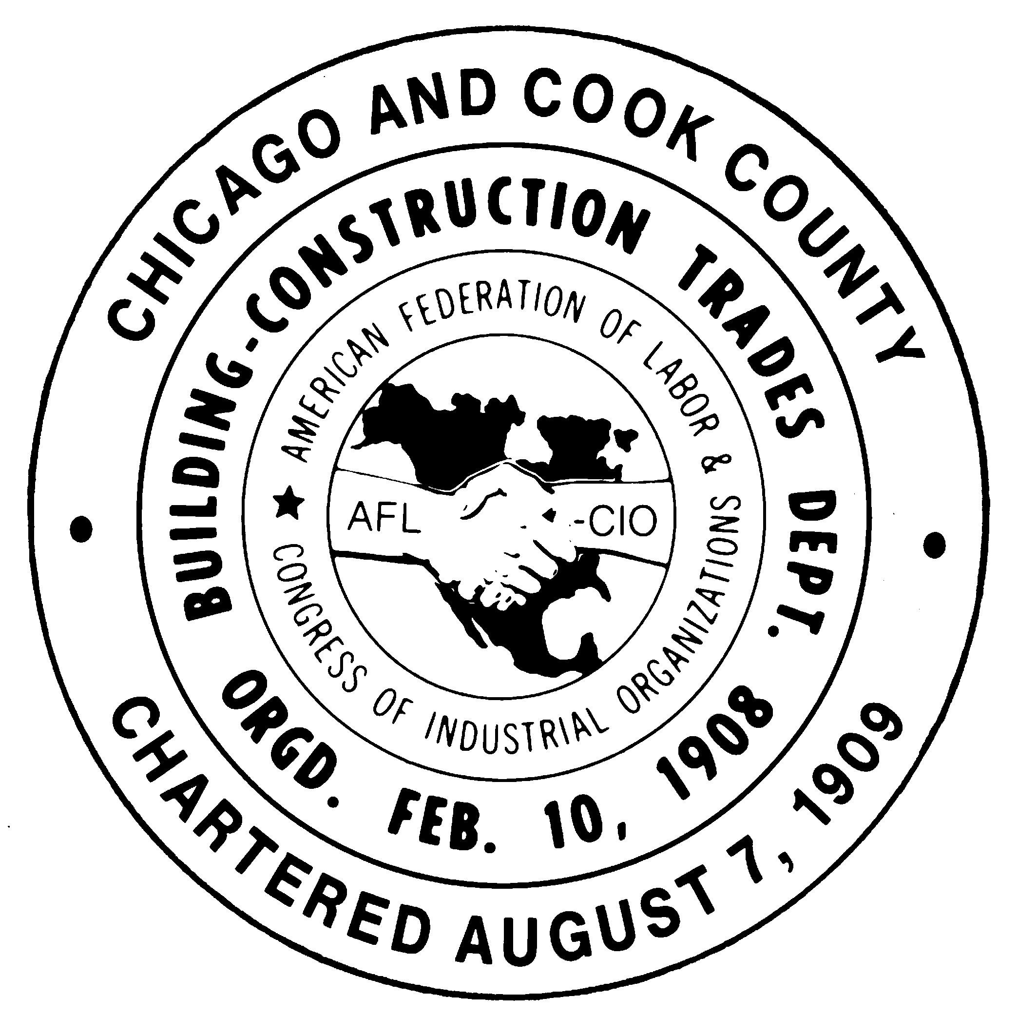

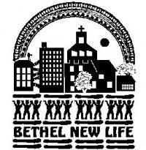
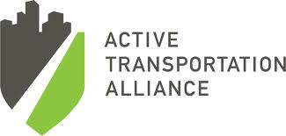
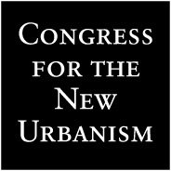



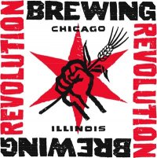



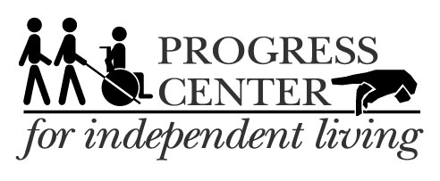





Businesses, Unions, + Organizations

